**PORT ST JOHNS MUNICIPALITY SECTION 52(d) REPORT QUARTER 3 OF 2024/25 FY**



**QUARTERLY REPORT FOR THE MONTH ENDED 31 MARCH 2025**

Contents

**1.** **Mayors Report** 4

**2.** **Consolidated view of the budget** 4

**3.** **Sources of Revenue** 7

**4.** **Debtors Report** 13

**5.** **Revenue enhancement Strategy** 17

**6.** **Grants Performance** 18

**7.** **Expenditure Management** 18

**8.** **Creditors** 23

**9.** **Cash and cash equivalents.** 24

**10 .Cash flow Statement**……………………………………………………………………………………………………………25

**11.** **SCM Deviations** 27

**12. Unauthorised, Irregular, Fruitless and wasteful expenditure** 27

**13.** **Cost containment report** 28

**14.** **Assets Management summary** 29

15.Progress on Audit Action Plan 32

16. **Indigent Registration and Indigent Support** 32

**17. In-year Budget Statement Tables** 36

Annexures: 48

**QUARTERLY BUDGET REPORT FOR THE MONTH ENDED 31 MARCH 2025**

**PURPOSE**

The purpose of this report is on the financial performance of the municipality as per Section 52 (d) of the MFMA for the quarter ending 31 March 2025.

**LEGAL/STATUTORY REQUIREMENTS**

Section 71 of Municipal Finance Management Act No. 56 of 2003.

Section 52(d) of Municipal Finance Management Act No. 56 of 2003.

Municipal Budget and Reporting Regulations gazette No 32141

**AUTHORITY**

Port St Johns Municipal Council

**BACKGROUND**

Sec 52(d) of the MFMA states; that “the mayor of a municipality must, within 30 days of the end of each quarter, submit a report to the Council on the implementation of the budget and the financial state of affairs of the municipality.”

The MFMA’s Municipal Budget and Reporting Regulations Section 31 states that the quarterly budget statement of a municipality must be in the format specified in Schedule C and include all the required tables, charts and explanatory information, taking into account any guidelines issued by the Minister in terms of section 168(1) of the act.

# **Mayors Report**

Section 52 (d) stipulates that the mayor of the municipality must, within 30 days of the end of each quarter, submit a report to council on the implementation of the budget and the financial situation of the municipality.

Comments from the Mayor

# **Consolidated view of the budget**

The Municipality has a total approved budget of 528 million for revenue and expenditure. To- date the municipality has spent 56.7% of the 12 months budgeted amount. For the third quarter the budget spending against year-to-date budget is sitting at 68.38% for expenditure. Employee related costs which are one of our cost drivers is 71.99% of the budget amount for Q3. The billing for rates and services for Q3 is R3,750,000.00 and the amount collected is R370,764.80 In total the municipality has received 9.88 % of the quarterly budgeted funds. Own revenue for the quarter is sitting at 3,6 million. This makes revenue less than what was budgeted for by 71% of own revenue. This is due to the annual billing and low collection on other own revenue items

The table below shows the actual revenue, and expenditure amounts for the month ending 31 March 2025. The bottom line shows a surplus of 47 million which means that the municipality’s expenditure is less that the revenue. The revenue includes capital grants received in Q3.



# **Sources of Revenue**

The Municipality generates revenue from the below listed sources which included government grants. Rates are billed annually and other services monthly. The municipality is dependent on grants as reflected in the below table that grant income constitutes 75% of the total revenue. The municipality has received all the gazetted funds for Q3 and the own revenue in total has improved than estimated due to the annual billing for rates, investments accounts and the VAT refunds received.

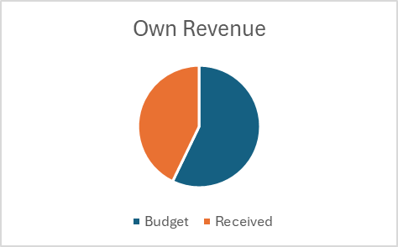

The below table shows the detailed revenue streams and their performance against budget for Q3 number of internal revenue sources have underperformed and the reasons for variances are listed below.

|  |  |  |  |  |  |  |  |  |  |
| --- | --- | --- | --- | --- | --- | --- | --- | --- | --- |
|  |  |  |  |  |  |  |  |  |  |
| **Item** | **Budget 2024/25** | **Q3 projections** | **Jan-25** | **Feb-25** | **Mar-25** | **Actual revenue Q3** | **Actual Revenue Variance** | **% Collected** | **Variance Explanation** |
| Assessment Rates | (15,000,000) | 3,750,000.00 | (134,666.77) | (116,481.40) | (119,616.68) | **370,764.85** | (3,379,235.15) | 9.89% | Decrease is due to dishonoured payment arrangement by debtors |
| Refuse Removal | (1,500,000) | (375,000.00) | (34,873.82) | (40,523.66) | (74,113.43) | **149,510.91** | (225,489.09) | 40% | Ratepayers are reluctant to pay, the municipality is in the process of appointing a debt collector through a transversal process. |
| Short Term Investments and Call Accounts | (20,000,000) | (5,000,000.00) | (4,006,144.45) | (546,175.13) | (436,317.46) | **4,988,637.04** | (32,254.07) | 99% | Due to decrease in bank balances |
| Property Rates (interest received from debtors) | (5,550,000) | (1,387,500.00) | (408,853.65) | (410,220.45) | (411,617.49) | **1,230,691.59** | (156,808.41) | 89% | Slight decrease is due to non- payment of arrear debt. |
| Court Fines | (300,000) | (75,000.00) | (31,810.00) | - | (600.00) | **32,410.00** | (42,590.00) | 43% | The department needs to improve as this has been going on for some time. |
| Vehicle Registration | (1,500,000) | (375,000.00) | - | - | - | **-** | (375,000.00) | 0% | Not yet Functional |
| Drivers license application/duplicate drivers license | (600,000) | (150,000.00) | - | - | - | **-** | (150,000.00) | 0% | Not yet Functional |
| Leaners license application | (350,000) | (87,500.00) | (30,648.00) | (39,805.00) | (39,385.00) | **109,838.00** | 154,748.00 | 177% | A slight increase has been noted, and the end user department must keep it up. |
| sale of goods -Assets < Capitalisation Threshold (Auction) | (316,274) | (316,274) |  |  |  |  |  |  | The auction was done in the first quarter (done annually) |
| Driver's license: certificate | (300,000) | (75,000.00) | - | - | - | **-** | (75,000.00) | 0% | Not yet Functional |
| Business license: flee market and hawker stalls | (250,000) | (62,500.00) | (3,209.00) | (14,746.00) | (4,338.99) | **22,293.99** | (40,206.01) | 36% | The decrease is due to non-payment by hawkers in town. |
| Investment property: sub lease payment | (500,000) | (125,000.00) | (15,260.00) | (15,760.00) | (19,548.89) | **50,568.89** | (74,431.11) | 41% | Golf course, Polela and Luxolweni flats not paying. Legal intervention is required |
| Sales of Goods and Rendering of Services: Cemetery and Burial | (20,000) | (5,000.00) | (3,980.00) | - |  | **3,980.00** | (1,020.00) | 80% |  |
| Fines: Pound Fees | (75,000) | (18,750.00) | - |  |  | **-** | (18,750.00) | 0% | Not yet Functional |
| Publications: Tender Documents | 20,980 | 5,245.00 | 938.00 |  |  | **938.00** | 4,307.00 | 0% | No sales as documents are available online be adjusted during adjustment budget |
| Sales of Goods and Rendering of Services: Application Fees for Land Usage | (15,000) | (3,750.00) | - |  |  | **-** | (3,750.00) | 0% | No applications regarding land use restrictions were filed this quarter. |
| Fines: Building | (5,000) | (1,250.00) | - |  |  | **-** | (1,250.00) | 0% | Due to bylaws that are not **gazetted**, illegal land use activities are not enforceable. The bylaws are in the process of being gazetted |
| Sales of Goods and Rendering of Services: Encroachment Fees | (5,000) | (1,250.00) | - |  |  | **-** | (1,250.00) | 0% | Due to bylaws that are not **gazetted**, illegal land use activities are not enforceable. The bylaws are in the process of being gazetted |
| Sales of Goods and Rendering of Services: Building Plan Approval | (20,980) | (5,245.00) |  |  |  |  | (5,245.00) | 0% |  |
| Sales of Goods and Rendering of Services: Advertisements | (120,000) | (30,000.00) | - |  |  | **-** | (30,000.00) | 0% | Due to bylaws that are not gazetted, illegal land use activities are not enforceable. The bylaws are in the process of being gazetted |
| Revenue: Exchange Revenue - Sales of Goods and Rendering of Services - Building Plan Clause Levy | (35,000) | (8,750.00) | - |  |  | **-** | (8,750.00) | 0% | Due to bylaws that are not gazetted, illegal land use activities are not enforceable. The bylaws are in the process of being gazetted |
| Transaction Handling Fees | (100,000) | (25,000.00) | - |  |  | **-** | (25,000.00) | 0% |  |
| Revenue: Exchange Revenue - Operational Revenue - Insurance Refund | (15,735) | (3,933.75) |  | (286,038.72) |  | **286,038.72** | 282,104.97 | 7171% |  |
| Other income- Rent Halls | (220,899) | (55,224.75) | (2,720.00) | (5,332.99) | (31,933.78) | **39 986.77** | (15,237.98) | 72% |  |
| LG Seta | (126,012.19) | (10,501.02 |  |  | (79,033.78) | **79,033.78** | 68,532.76 |  |  |
| VAT refund | (10,000,000) | (2,500.000.00) | (2,046,832.44) | - | (2,474,916.00) | **4,521,748.44** | 3,688,415.44 |  |  |
| **TOTALS** | **##########** | **(12,778,482.50)** | **(6,719,936.13)** | **(928,908.22)** | **(3,255,104.04)** | **(11,865,549.87)** |  |  |  |
|  |  |  |  |  |  |  |  |  |  |
|  |  | **ALLOCATIONS** | |  |  |  |  |  |  |
| **ITEM** | **Budget 2024/25** | **Monthly Projections** | **Jan-25** | **Feb-25** | **Mar-25** | **Received up to date** | **Variance** | **Variance Explanation** |  |
| Equitable Share | (203,985,000) | (67,995,000.00) | - | - | (50 996 000.00) | (203,973,000.00) | (12,000.00) |  |  |
| Local Government Financial Management Grant | (2,600,000) | (2,600,000.00) | - | - | - | (2,600,000.00) | - | All monies received |  |
| Expanded Public Works Programme Integrated Grant | (1,676,000) | (419,000.00) | - | (502,000.00) | - | (1,676,000.00) | - | All monies received |  |
| Municipal Infrastructure Grant | (39,862,000) | (9,965,500.00) | - | - | (6,822,000.00) | (39,862,000.00) | - | All monies received |  |
| Integrated National Electrification Programme Grant | (31,277,000) | (7,819,250.00) | - | (10,000,000) | - | (31,277,000.00) | - | All monies received |  |
| Grant Gov-DSRAC Library | (1,003,000) | (83,583.33) | - | - | - | (1,003,000.00) | - | All monies received |  |
| OTP | (15 000 000) |  | - | - | (3,338,735.75) | (10,345,036.59) | (4,654,963.41) |  |  |
| Transport | (12 000 000) |  | - | (1,708,292.94) | (2,591,625.03) | (4,299,917.97) | (7,700,082.03) |  |  |
| Municipal Disaster Response Grant | (57,737,686) | (4,811,473.83) | - | - | (20,507,000.00) | (25,634,000.00) | (32,103,686) |  |  |
| **TOTALS** | **(306,037,000.00)** | **(114,516,333.33)** | **-** | **(12,210,292.94)** | **(84,255,360.78)** | **(318,078,329.53)** | **(44,470,731.44)** |  |  |
|  |  |  |  |  |  |  |  |  |  |

**Services, rates and taxes**

* The services offered by the municipality to its residents represent exchange transactions such as, refuse removal, leased properties, building plan fees etc whilst the none exchange transactions are represented by rates, traffic fines and others. The collection on rates for Q3 is **R370 thousand for all categories and is** less than the year-to-date projections of **R3,7**million and for refuse collection **150 thousand** has been collected and is less than the year-to-date projections of **R732** thousand.
* The department engaged its debtors in all categories to reduce their historic debt by making monthly payment arrangements. Honouring of the arranged payments is still a challenge.
* The municipality received a total VAT refund of R4,521,748.44 **in Q3**
* All municipal debt is being collected internally by revenue section for residential debtors, businesses and government departments.
* The institution received an amount of **R61,944.97.** from the department ofNational Public Works and no payment received from department of Provincial Public Works for Q3.
* The institution has one employee owing municipal rates which is not allowed in terms of Schedule 2 (10) of the code of conduct of municipal staff members and the amount owed is **R94 814.68**
* The institution collected an amount of **R32,410.00 as opposed to the 75 000 targets** on traffic fines for Q3 and it is advisable that the end user department must have a plan on how to improve on the collection as it was noted in the previous quarters that collection was unsatisfactory.
* Learner's licences and vehicle registration collected an amount of **R109,838.00 as compared to budget of 87 500 this shows an improvement for Q3.**
* The institution received an amount of **R4,988 637.04** from interest on investments accounts.
* All other revenue collection items are detailed in the table above**.**

# **Debtors Report**

The Municipality had a total consumer debtors balance of R78 646 731 for Q3 This balance is consisting of rates and refuse. 95.94% of the debtor’s balance is older than 90 days meaning that the recoverability of this debt is uncertain. The municipality continues to engage and encourage debtors to pay. Below is the Age Analysis report showing that the households owe 42.75% of the total debt followed by government at 38.99% then businesses 18.26%.

**Government debt is consisting of the following**

|  |  |  |  |  |  |  |  |
| --- | --- | --- | --- | --- | --- | --- | --- |
| **Department** |  |  |  |  |  |  |  |
| **Provincial Public Works** | **Analysis of Debt** | **Current** | **30 Days** | **60 Days** | **90 Days** | **120 Days +** | **Total** |
|  |  | 16,793.04 | 6,906.53 | 6,869.88 | 6,869.88 | 21,148,448.02 | 21,185,887.35 |
|  | **Total** | **16,793.04** | **6,906.53** | **6,869.88** | **6,869.88** | **21,148,448.02** | **21,185,887.35** |
| **Department** |  |  |  |  |  |  |  |
| **National Public Works** | **Analysis of Debt** | **Current** | **30 Days** | **60 Days** | **90 Days** | **120 Days +** | **Total** |
|  |  | 47,870.90 | 23,935.45 | 23,935.45 | 23,935.45 | 6,313,339.34 | 6,440,213.27 |
|  | **Total** | **47,870.90** | **23,935.45** | **23,935.45** | **23,935.45** | **6,313,339.34** | **6,440,213.27** |

**Top 10 Debtors**

Below table shows the top 10 debtors on the age analysis. They are on the priority list for collection. We have a challenge that commitments made by the debtors are very small to reduce the debt. With the engagement of the debt collector, we hope to see a movement on the top 10 debtors.

**Top 10 Debtors**

|  |  |  |  |  |  |  |  |  |  |
| --- | --- | --- | --- | --- | --- | --- | --- | --- | --- |
| **ACCOUNT** | **C/CODE** | **CURRENT** | **30 Days** | **60 Days** | **90 Days** | **120+ Days** | **Movement** | **Total** | **ACCOUNT NAME** |
| 10000980 | HOUSEHOLD | 0.00 | 0.00 | 0.00 | 185,020.00 | 3,479,460.83 | +17,238.74 | **3,664,480.833** | Dorothy Lilly Morris |
| 30000364 | GOVERNMENT- PROVINCIAL | 0.00 | 0.00 | 0.00 | 73,578.56 | 794,852.53 | +5,687.08 | **868,431.09** | Mdlankala JSS |
| 20001241 | GOVERNMENT- NATIONAL | 0.00 | 0.00 | 0.00 | 0.00 | 658,052.05 | +3,135.48 | **676,865.71** | NATIONAL P. WORKS |
| 10002094 | GOVERNMENT- PROVINCIAL | 0.00 | 0.00 | 0.00 | 159,640.00 | 499,473.64 | +2,497.86 | **659,113.64** | Government of Transkei |
| 10000019 | BUSINESS | 0.00 | 0.00 | 0.00 | 23,180.00 | 540,870.37 | +3,496.79 | **564,050.37** | QUMA FUNERAL SERVICES CC |
| 10000843 | GOVERNMENT- NATIONAL | 0.00 | 0.00 | 0.00 | 12,650.00 | 518,832.52 | +1,982.77 | **531,482.52** | NATIONAL PUBLIC WORKS |
| 10001060 | BUSINESS | 3,358.33 | 3,358.33 | 3,358.33 | 3,358.33 | 492,987.26 | +2,484.94 | **526,570.56** | LADHOW TRUST |
| 30000385 | GOVERNMENT- PROVINCIAL | 0.00 | 0.00 | 0.00 | 138,517.50 | 381,415.64 | +2,888.34 | **519,933.14** | Lutshaya SSS |
| 30000419 | GOVERNMENT- PROVINCIAL | 0.00 | 0.00 | 0.00 | 139,305.00 | 354,210.80 | +2,321.66 | **493,515.80** | Kwamsikwa JSS |

**Collection rate**

The collection rate below is calculated on billing vs revenue collected however when calculating revenue collected vs debtors balance the collection rate of the municipality comes to an overall rate of 9%.

|  |  |  |  |  |  |  |  |
| --- | --- | --- | --- | --- | --- | --- | --- |
| **Description** | **Annual Budget** | **Q3 Billing** | **January Collection** | **February Collection** | **March Collection** | **Q3 Collection** | **% Collection** |
| Assessment rates | 15,000,000.00 | 3 750 000 | 134,666.77 | 116 481.40 | 119 616.68 | 370 764.85 | 9.88% |
| Refuse Removal | 1,500,000.00 | 375 000 | 34,873.82 | 40 523.66 | 74 113.43 | 149 510.91 | 40% |

**Status of employees with arear debt.**

The institution has one employee owing municipal rates which is not allowed in terms of Schedule 2 (10) of the code of conduct of municipal staff members and the amount owed amounts to **R94 814.68**. An arrangement has been done between the employee and the Municipality.

# **Revenue enhancement Strategy**

There was no scheduled Revenue enhancement steering committee meeting for the third quarter.

**Compilation of the General Valuation Roll**

Port St Johns Municipality has started a process of compiling the general valuation roll for a period of 5 years, the valuation process has started and is done by Gov- pro and the date of implementation will be the 1st of July 2025.

The service provider submitted the Draft General Valuation Roll to the municipality on the 28th of February 2025 and the Municipality reviewed the draft GV. There were corrections to be made by the valuer and the certified valuation roll was sent to the municipality on the 31st of March 2025.

# **Grants Performance**



The above table shows grants received to date and the expenditure on grants the municipality is expected to have spent 75 % of the funds received however as seen above the municipality has overspent on a few of the conditional grants and underspent in majority which is unfavourable for the municipality but certain grants were only allocated to the municipality in the second quarter of the financial year.

# **Expenditure Management**

Total expenditure for Q3 is R90 968 313.00 and this included both capital and operational expenditure. Most of the expenditure for the third quarter comes from Infrastructure Engineering at 32% Community Services at 17%, followed by financial services 14%.

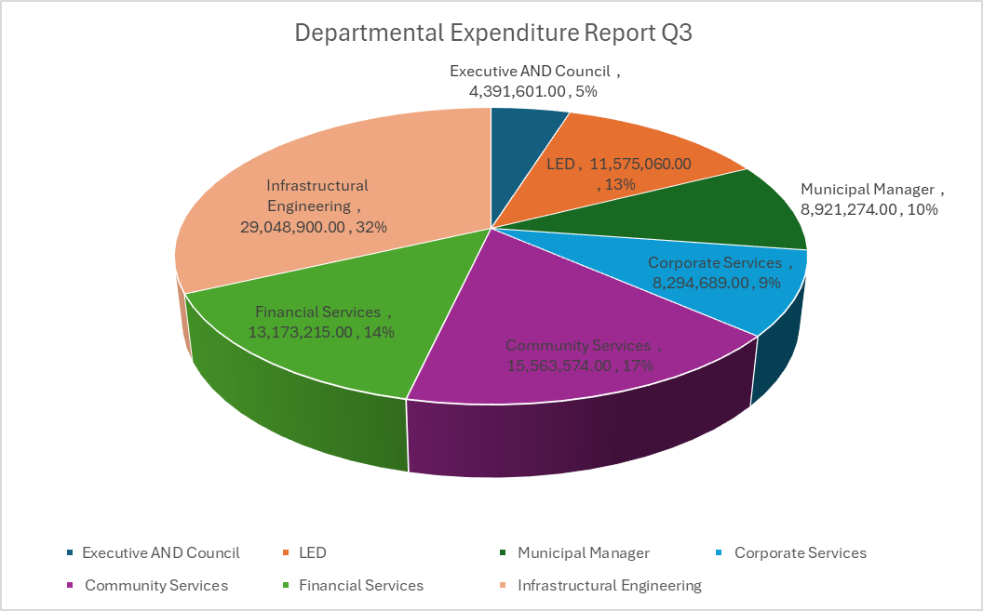

|  |  |  |  |  |  |  |  |
| --- | --- | --- | --- | --- | --- | --- | --- |
| **Expenditure per category** | **Budget 2024/25 R** | **Quarterly Budget** | **Actual Exp Jan** | **Actual Exp Feb** | **Actual Exp March** | **Q3 Total Expenditure** | **Variance** |
| Employee Related Costs | R132 671 111.00 | R33 167 777.75 | R12 569 594.00 | R10 852 038.00 | R10,459,943 | R33,881,575 | (713,797.25) |
| Operational Cost | R70 549 423.00 | R17 637 355.75 | R6 596 148.00 | R7 546 012.00 | R14 590 799 | R28 732 959 | (11,095,603.25) |
| Fuel and Oil | R8 765 000.00 | R2 191 250.00 | R474 389.88 | R602 907.09 | R600 850.93 | R1 678 147.90 | 513,102.10 |
| Allowances | R3 293 460.00 | R823 365.00 | R382,495.81 | R367,736.21 | R375,236.21 | R1 125,468.23 | (302,103.23) |
| Consultants | R8 687 399.00 | R2 171 849.00 | R41 975 | R177 287.32 | R336 372.83 | R555 635.15 | 1 616,213.85 |
| Repairs and Maintenance | R24 452 932.00 | R6 113 233.00 | R1 136 417.00 | R584 156.80 | R787 168.58 | R2 507 742.38 | 3 605,490.62 |
| **TOTAL** | **R270 958 563.00** | **R67 739 640.00** | **R21,201,019.69** | **R20,130,137.42** | **R27,150,370.55** | **R68,481,527.66** | **(R6 376,697.16)** |

Table above shows expenditure incurred in the 3rd quarter highlighting employee costs being the highest followed by general expenditure. See the table above. The municipality must continue in making use of the cost containment measures to reduce the expenditure.

**Capital Expenditure**

Capital expenditure to date is R 106 228 057 inclusive of R18 591 374 million funded by own generated revenue year to date.

**Section 66 expenditure**

The total expenditure incurred up to date for employee related costs is R63 million and remuneration of councillors is R 7.3 million and the spending is within the budget of R74.6 million. An increase in salaries has been noted as the municipality implemented an annual increase of 1.5% to municipal staff and new appointments.

The Municipality also paid an amount of 964 247.07 for settlement of grievances. It must be noted that this amount was not budgeted for and has resulted in irregular expenditure as these amounts were not incurred in a manner prescribed by legislation and there were insufficient documents to support it.

The overtime amount is quite high as it above R500 000 and needs close monitoring. Employee costs make up 55% of the total operational expenditure and is above the norm of 40%. The municipality must find ways of reducing this % spending on employee costs

See the table below breakdown of costs

|  |  |  |  |  |
| --- | --- | --- | --- | --- |
| **MFMA Section 66 Monthly Report** |  |  |  |  |
|  |  |  |  |  |
|  |  |  |  |  |
| **TYPE OF EXPENDITURE** | **ACTUAL** | **ACTUAL** | **ACTUAL** | **YTD ACTUAL** |
|  | **Jan-2025** | **Feb-2025** | **Mar-2025** | **TOTAL** |
| Basic Salaries & Wages | 7,525,229.99 | 7,541,274.06 | 7,413,044.51 | 22,479,548.56 |
| Pension and UIF Contributions | 1,046,278.64 | 1,054,824.12 | 1,072,677.77 | 3,173,780.53 |
| Medical Aid Contributions | 614,330.24 | 622,205.24 | 618,649.64 | 1,855,185.12 |
| Other CC | 91,090.25 | 89,877.97 | 96,553.29 | 277,521.51 |
| Overtime | 2,417,122.38 | 607,204.24 | 399,307.42 | 3,423,634.04 |
| Bonus | 374,580.62 | 431,256.50 | 437,576.76 | 1,243,413.88 |
| Car Allowance | 382,495.81 | 367,736.21 | 375,236.21 | 1,125,468.23 |
| Housing Allowance | 4,830.80 | 4,830.80 | 4,830.80 | 14,492.40 |
| Other benefits and allowances | 912,432.47 | 691,678.33 | 799,283.16 | 2,403,393.96 |
| Leave payment | 148,264.94 | 10,219.92 | - | 158,484.86 |
| Long Service Awards | 16,848.29 | 20,448.13 | - | 37,296.42 |
| **TOTAL** | **13,533,504.43** | **11,441,555.52** | **11,217,159.56** | **36,192,219.51** |



# **Creditors**

In terms of the MFMA Section 65 (2) (e) all creditors should be paid within 30 days. The Municipality strives to pay all its creditors within the 30 days. Total amount outstanding as at end of March 2025 is R 648,903.73

Below are the top 5 creditors

|  |  |  |
| --- | --- | --- |
| # | Supplier | Amount |
| 1 | VUBA IMAGINEERS | 160,632.00 |
| 2 | LIKAMVA GEOMATICS | 59 ,600.00 |
| 3 | SUPAMIX DIY EL | 22 ,126.00 |
| 4 | C-TRACK | 208,567.30 |
| 5 | MAXIMUM PROFIT | 197, 978.43 |
|  | Total | 648 ,903.73 |

# **Cash and cash equivalents.**

At the end of March 2025, the Municipality had the below bank accounts and balances with FNB. The balances are inclusive of interest from call accounts.

|  |  |  |  |  |  |
| --- | --- | --- | --- | --- | --- |
| **Account Number** | **Bank** | **Account type** | **Acc. Name** | **Balance** | **Recons** |
| 63007016735 | FNB | Main Account | Port St Johns | 12,403,291.86 | 31/03/2025 |
| 63008238081 | FNB | Disaster Call Account | Port St Johns | 29,621,788.75 | 31/03/2025 |
| 63008239261 | FNB | Operational Account | Port St Johns | 31,676,629.02 | 31/03/2025 |
| 63008236407 | FNB | INEP Call Account | Port St Johns | 9,102,719.56 | 31/03/2025 |
| 63008237778 | FNB | MIG Call account | Port St Johns | 74,177.40 | 31/03/2025 |
| 63008239790 | FNB | Call Account | Port St Johns | 13,638,851.30 | 31/03/2025 |
| 76205998069 | FNB | Investment Account | Port St Johns | 41,664, 174.33 | 28/02/2025 |
| 388649569 | Standard Bank | Investment Account | Port St Johns | 60,000,000.00 | 31/03/2025 |
|  |  |  | **Total** | **147,048,609.42** |  |

**Interest Received from Investments**

The Municipality invests the unutilised revenue in interest generating call accounts and has earned an amount of R4,967,745.93 The table below shows a detail of interest earned in the quarter ended 31 March 2025.

|  |  |
| --- | --- |
| Month | Amount Earned |
| January | R4,006,144.45 |
| February | R546,175.13 |
| March | R415 426.35 |
| Total: | **R4,967,745.93** |

## **10. Cash flow Statement**

The table below highlights the cash flow position of the municipality for the third quarter of 2024/25. The year-to-date cash flow statement of the municipality depicts that the municipality has a favourable cash position.

The cash and cash equivalents to date show positive cash outlay of the municipality. This is however because of both conditional grants and equitable share paid. This situation is however not sustainable if the revenue collection is not improved.



# **SCM Deviations**

**Summary of Deviations for the Q3**

Below is the summary of deviations incurred for Q3; the detailed list is attached.

|  |  |  |
| --- | --- | --- |
| January | February | March |
| R 184 364,85 | **R 50 475,80** | **R 48 488,60** |

It is recommended that the deviations for Q3 be approved

|  |
| --- |
|  |

# **12. Unauthorised, Irregular, Fruitless and wasteful expenditure**

**Unauthorised Expenditure**

Unauthorised expenditure occurs when departments used more funds than had been allocated (in other words, overspending) or used allocated funds for purposes other than those intended.



Executive Council used more funds than allocated for purposes air transport and accommodation, Municipal Manager office utilised more than allocated for Radio and TV transmission and advertising budget road shows, corporate services utilised more than allocated for telephone and human resources management and Engineering used more than allocated for subsistence and travel daily allowance.

**Summary of Irregular Expenditure**

**Irregular expenditure** is expenditure incurred by a municipality or municipal entity in contravention of, or that is not in accordance with, a requirement of the legislative prescripts. Below is the summary of irregular expenditure incurred for Q3. For the second quarter a total of R2 100 316,03 for irregular expenditure was incurred, see the table below with detailed list.

|  |  |  |
| --- | --- | --- |
| Jan | Feb | March |
| R 438 000 | **R 843 385,93** | **R 818 930,10** |

The irregular expenditure relates to settlement of grievances paid without proper documentation, appointment of legal expert outside of the existing panel with SCM processes not being followed.

**Summary of Fruitless and wasteful expenditure**

Fruitless and wasteful expenditure refers to expenditure that was made in vain and could have been avoided had reasonable care been taken. Such expenditure includes interest, the payment of inflated prices, and the cost of litigation that could have been avoided.

|  |  |  |  |
| --- | --- | --- | --- |
| **Jan** | **Feb** | **March** | **Total Q 3** |
| R 489.74 | R0 | R 215 900.53 | R216 390.27 |

The amount for fruitless and wasteful expenditures consists of interest from Eskom, Telkom and SARS.

# **Cost containment report**

The municipality has a cost containment policy which gives guidance for the municipality to achieve cost savings. See below Table for Q3.

|  |  |  |  |  |
| --- | --- | --- | --- | --- |
| **Description** | **Budgeted amounts** | **Quarterly Budget** | **Expenditure Q3** | **Variance** |
| S&T | 4,745,683.00 | 1,186,420.75 | 281,646.44 | 904,774.31 |
| Accommodation | 5,168,096.00 | 1,292,024.00 | 1 470,687.84 | (178,663.84) |
| Catering Services | 3,441,187.00 | 860,296.75 | 964,569.10 | (104,272.35) |
| Communications | 650,000.00 | 162,500.00 | 285,794.00 | (123,294) |
| Gift and Promotional items | 350,000.00 | 87,500.00 | 61,548.16 | 25,951.84 |
| **Totals** | **14,354,966.00** | **3,588,741.50** | **3,064,245.54** | **524,495.96** |

# **Assets Management summary**

|  |  |  |  |  |  |
| --- | --- | --- | --- | --- | --- |
| **FAR Summary as of 31 March 2025** | | | | | |
| **Category** | **Opening Bal** | **Additions** | **Disposal** | **Accumulated Depreciation** | **Carrying Value** |
|  |  |  |  |  |  |
| Buildings | 20,290,546 | - | - | 7,582,575 | 12,657,971 |
| Community assets | 56,296,041 | - | - | 19,783,799 | 36,512,242 |
| Furniture and fixtures | 3,639,773 | 35,000.00 | - | 2,829,842 | 844,931 |
| IT equipment | 8,296,138 |  | - | 7,458,770 | 837,368 |
| Infrastructure | 737,227,890 | - | - | 451,244,344 | 285,983,563 |
| Infrastructure - WIP | 198,082,711 | 5,221,454 | - | - | 203,304,165 |
| Land | 73,876,552 | - | - | - | 73,876,552 |
| Plant and machinery | 50,694,995 |  | - | 42,977,536 | 7,717,459 |
| Heritage Assets2 | 123,700 | - | - | - | 123,700 |
| Transport assets | 14,397,464 |  | - | 6,014,289 | 8,383,175 |
|  | **1,162,875,827** | **5,256,454** | **-** | **537,891,156** | **630,241,125** |

**Insurance**

* All the Municipal assets are insured with Mpumelelo Financial Services.
* There are currently two (2) outstanding insurance claims. The insurance annual premium has increased to R1.9 million due to high rate of the insurance claims and the municipality has been flagged as high risk.

**STORES Management**

* Inventory management is done at Municipal Stores which are situated at Municipal warehouse offices.
* At Stores we are having different types of inventories classified as follows:
* Fuel and oil (e.g Petrol)
* Cleaning Material (e.g Refuse bags)
* Mechanical tools (e.g Tyres)
* Gardening (e.g. Bush Knives)

**SUMMARY OF INVENTORY STOCK AS AT END OF QUARTER 3**

|  |  |
| --- | --- |
| **ITEM** | **AMOUNT** |
| **Opening balance as of 1st March** | **R2,352,537.95** |
| **Purchases** | **R529,421.00** |
| **Issued** | **(R 380,118.24)** |
| **Closing balance as of 31 March** | **R2,532,004.76** |

For the month of March 2025, there’s no inventory items reported lost.

**Fleet Management**

The municipality spends a lot on fuel usage as seen in the table below. The risk of misuse on fuel is still high and it is advisable that all Managers should assist in managing this risk in their respective departments. The biggest consumer of fuel is the engineering department both for Machines and vehicles. All vehicles had their tracker units fixed except for the excavator that could not be reached due to location constraints.

|  |  |  |  |  |
| --- | --- | --- | --- | --- |
|  | **January** | **February** | **March** | **Total Amount** |
|  | **R 528 942,77** | **R 458 752,62** | **R 726 944,41** | **R 1 714 639,50** |

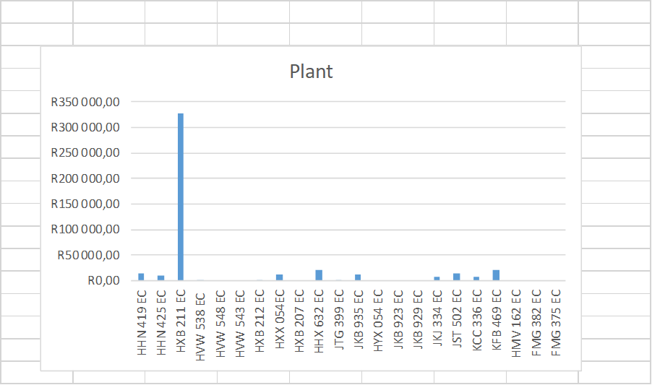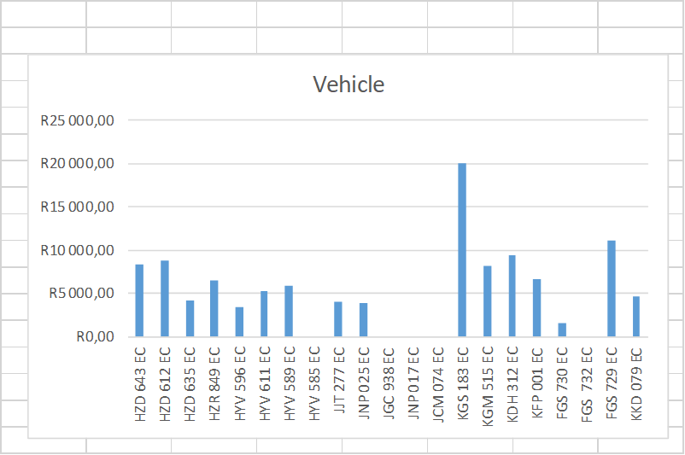

# 15.Progress on Audit Action Plan

The Municipality has an audit action plan to address the audit findings. To date the municipality has attended to all the findings that were issued by AG (SA). Detailed audit action plan is attached

# 16. **Indigent Registration and Indigent Support**

**Indigent Registration**

In quarter two the total number of indigent register was 18 043, in quarter three there were 61 new registrations that was collected from various wards leading to the total number of 18 104 indigents in our register for 2024/25 financial year, see table below:

|  |  |  |  |
| --- | --- | --- | --- |
| **Ward** | **O/B of indigents** | **Additions** | **Total No. of Indigents** |
| Ward 01 | 1286 | 00 | 1286 |
| Ward 02 | 827 | 16 | 843 |
| Ward 03 | 1106 | 01 | 1107 |
| Ward 04 | 1112 | 01 | 1113 |
| Ward 05 | 727 | 00 | 727 |
| Ward 06 | 622 | 03 | 625 |
| Ward 07 | 1201 | 00 | 1201 |
| Ward 08 | 1119 | 00 | 1119 |
| Ward 09 | 748 | 00 | 748 |
| Ward 10 | 967 | 00 | 967 |
| Ward 11 | 632 | 25 | 657 |
| Ward 12 | 816 | 00 | 816 |
| Ward 13 | 834 | 04 | 838 |
| Ward 14 | 630 | 00 | 630 |
| Ward 15 | 540 | 00 | 540 |
| Ward 16 | 1025 | 07 | 1032 |
| Ward 17 | 1100 | 02 | 1102 |
| Ward 18 | 1062 | 00 | 1062 |
| Ward 19 | 955 | 02 | 957 |
| Ward 20 | 734 | 00 | 734 |
| **Total** | **18 043** | **61** | **18 104** |

* 1. **Indigent Support**

The municipality offers the following services to our indigents: Free basic electricity, alternative energy and refuse removal. The total number supplied with FBE for quarter three was 10 178 as per the schedule received from Eskom. Alternative energy was supplied to all the twenty wards and 1053 beneficiaries benefited. Refuse collection was rendered at Ward 6 and 1332 indigents benefited for the quarter, see the table below:

|  |  |  |  |  |
| --- | --- | --- | --- | --- |
| **Wards** | **No. of people receiving FBE** | **No. of people receiving Alternative Energy** | **No. of people receiving refuse removal** | **Total** |
| Ward 1 | 499 | - | - | 499 |
| Ward 2 | 875 | - | - | 875 |
| Ward 3 | 753 | - | - | 753 |
| Ward 4 | 322 | - | - | 322 |
| Ward 5 | 330 | - | - | 330 |
| Ward 6 | 370 | - | 1332 | 1702 |
| Ward 7 | 782 | - | - | 782 |
| Ward 8 | 374 | - | - | 374 |
| Ward 9 | 557 | - | - | 557 |
| Ward 10 | 471 | - | - | 471 |
| Ward 11 | 402 | - | - | 402 |
| Ward 12 | 473 | - | - | 473 |
| Ward 13 | 503 | - | - | 503 |
| Ward 14 | 382 | - | - | 382 |
| Ward 15 | 520 | - | - | 520 |
| Ward 16 | 498 | - | - | 498 |
| Ward 17 | 538 | - | - | 538 |
| Ward 18 | 558 | - | - | 558 |
| Ward 19 | 424 | - | - | 424 |
| Ward 20 | 547 | - | - | 547 |
| **Total** | **10 178** | **-** | **1332** | **11 510** |
|  |  |  |  |  |

* Delivery of Alternative Energy was done during the month of February 2025 by the two service providers, and they were appointed for a period of one year which is expiring in March 2025.
* O.R. Tambo District Municipality working with its local municipalities, FBS Officer attended a meeting FBS District Forum in Mthatha during the month of February and March 2024. The main issues were to discuss how local municipalities are working and to adopt best practise. Customer Care drive and Indigent Registration Drive were other main agenda items where O.R. Tambo was in a process of visiting local municipalities to service their customers more especially in water and sanitation.

# **17. In-year Budget Statement Tables**

As per section 9 of the MBRR Schedule C attachment, the in-year budget statement tables must consist of the tables in the Attachments to this Schedule, namely –

(a) Table C1 s71 Monthly Budget Statement Summary



(b) Table C2 Monthly Budget Statement - Financial Performance (standard classification)



(c) Table C3 Monthly Budget Statement - Financial Performance (revenue and expenditure by municipal vote)



(d) Table C4 Monthly Budget Statement - Financial Performance (revenue and expenditure)



(e) Table C5 Monthly Budget Statement - Capital Expenditure (municipal vote, standard classification and funding)



(f) Table C6 Monthly Budget Statement - Financial Position



(g) Table C7 Monthly Budget Statement - Cash Flow



# Annexures:

* C SCHEDULE
* SCM implementation report
* SCM POE
* Deviations register
* FW register
* Supplementary valuation Roll
* Irregular expenditure
* SDBIP